**TASK1**

1. TRY TO FIND ALL FILES NECESSARY FOR SUCCESSFUL BOOT PROCESS IN YOUR SYSTEM

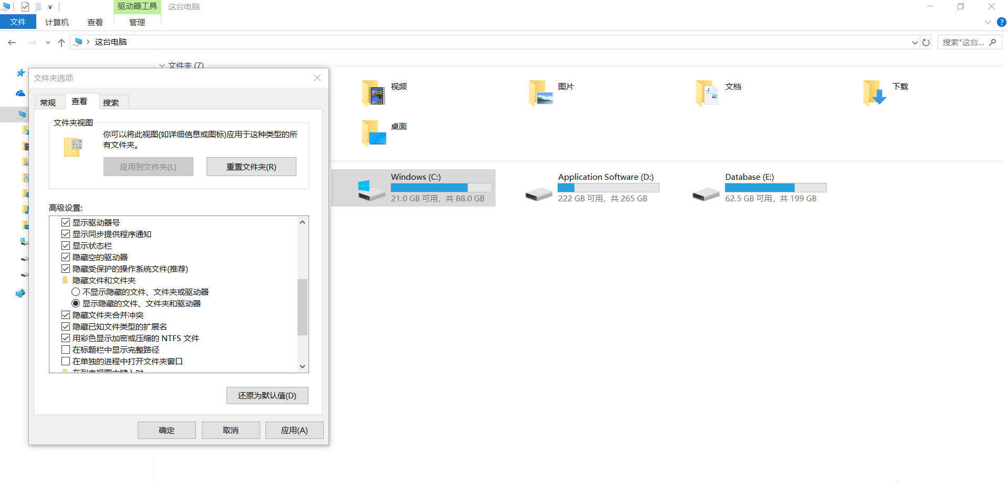

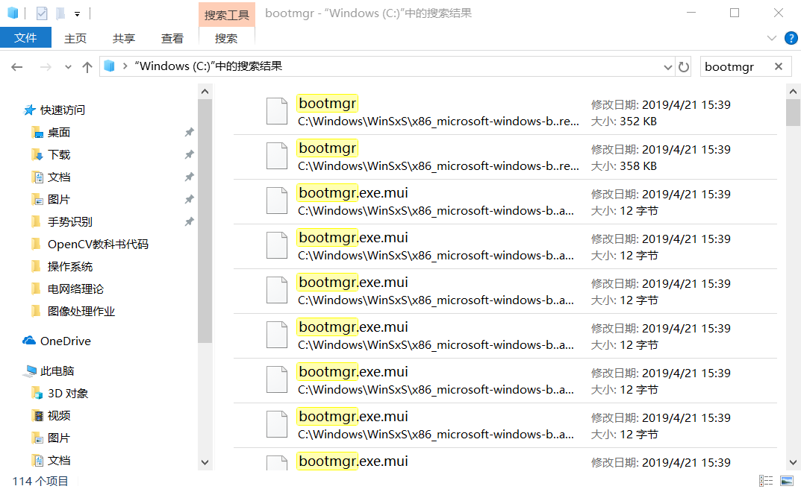

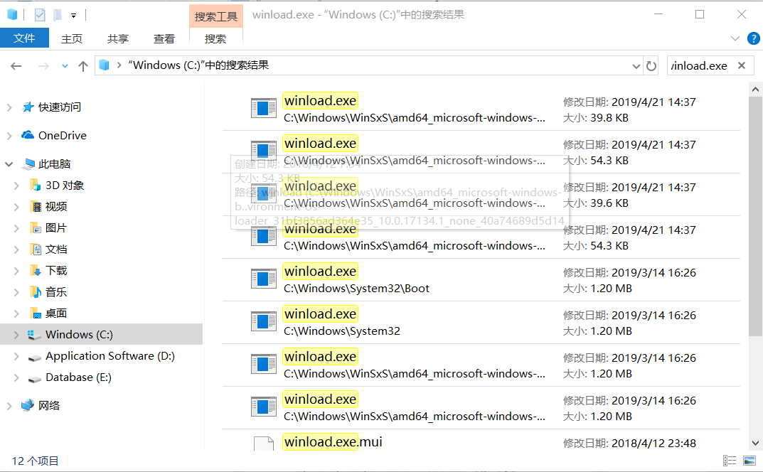

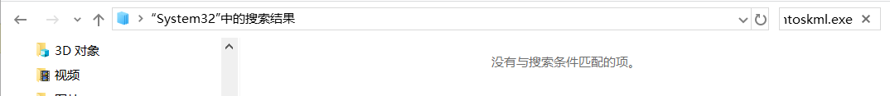

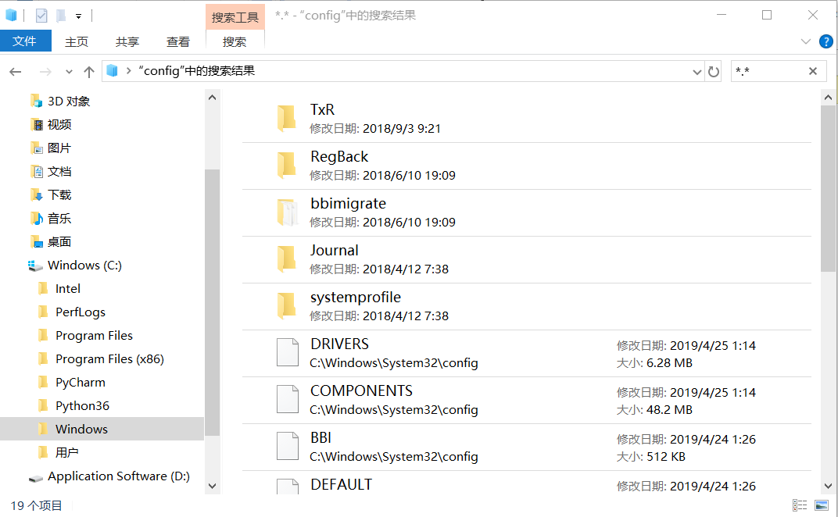

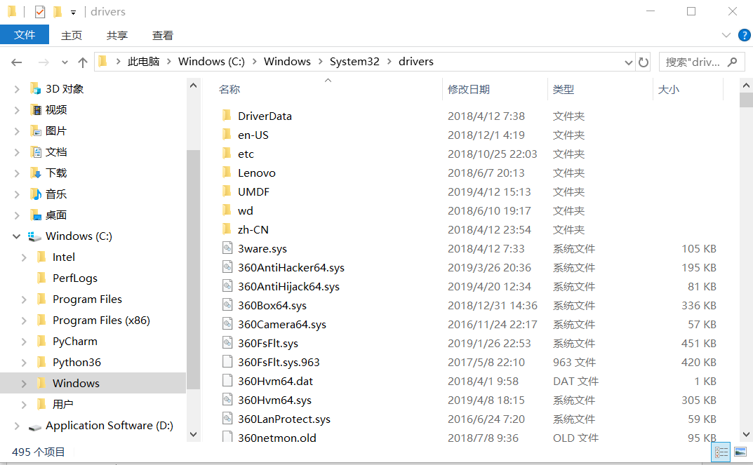

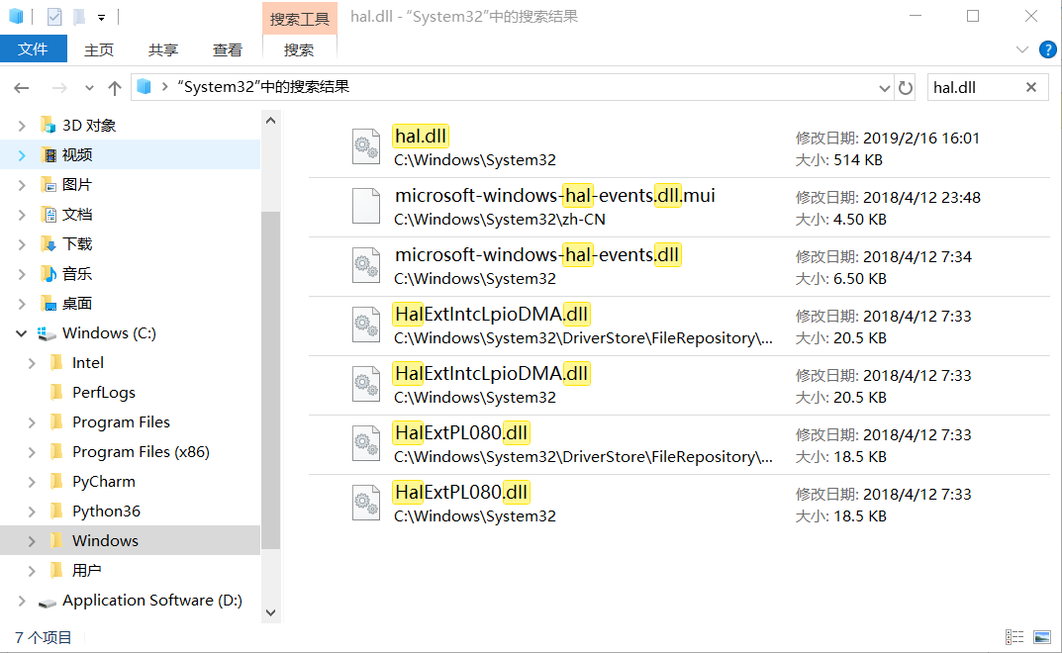

1. CREATE SEVERAL MMC(S) WITH DIFFERENT SET OF SNAP-IN(S)

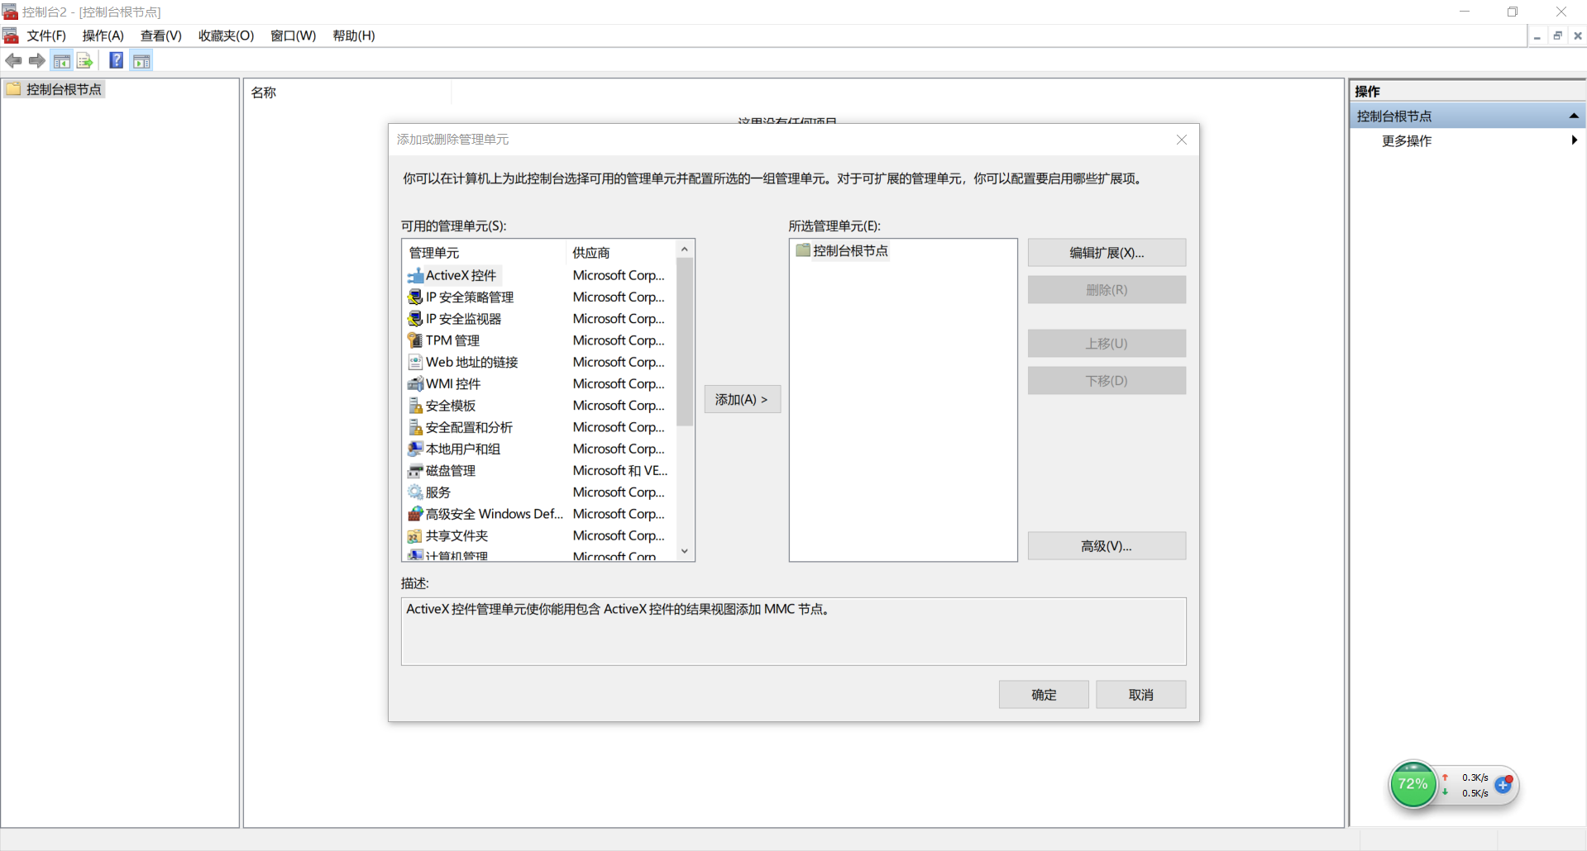

1. CREATE A NEW USER ACCOUNT WITH THE PASSWORD THAT NEVER EXPIRES

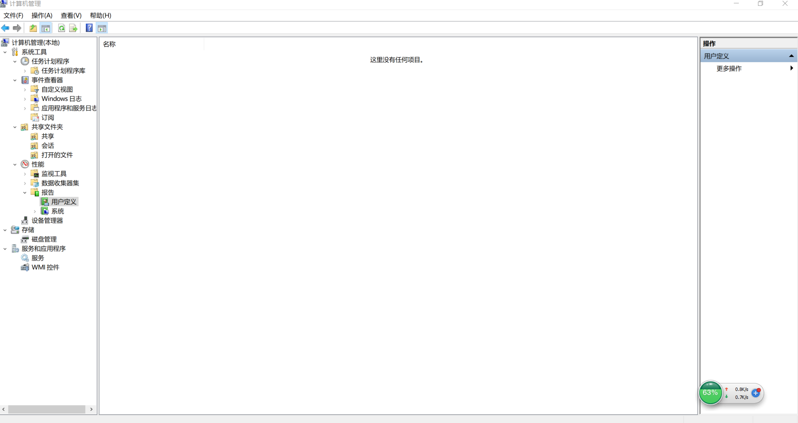

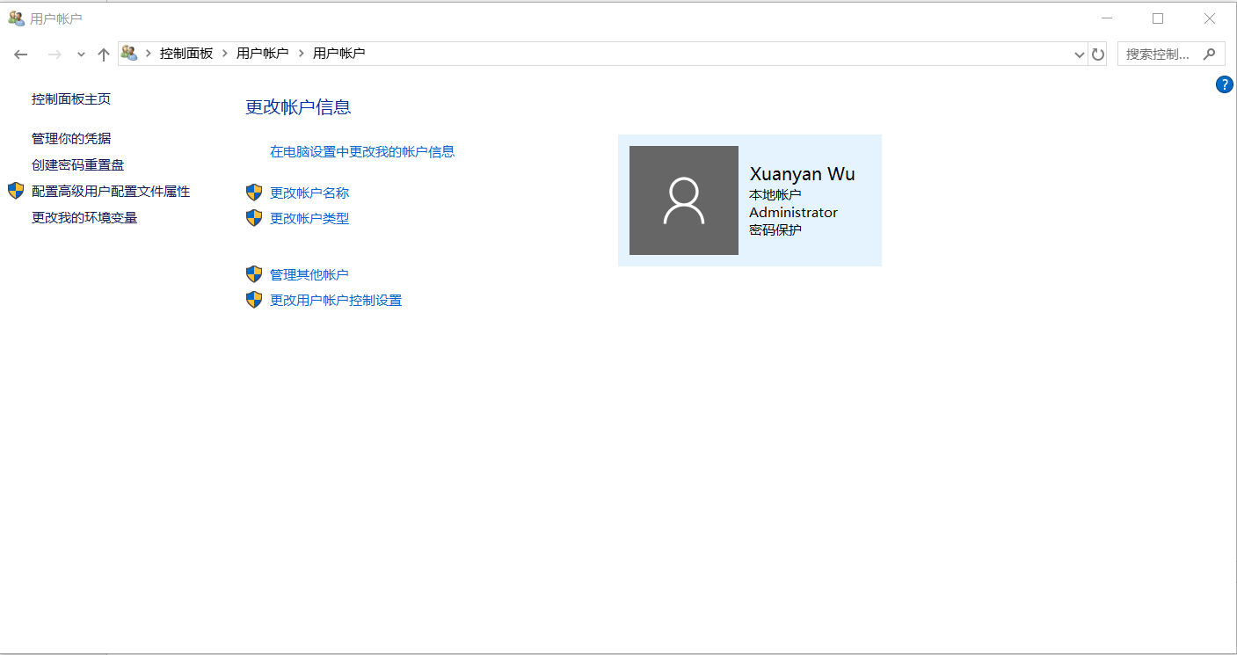

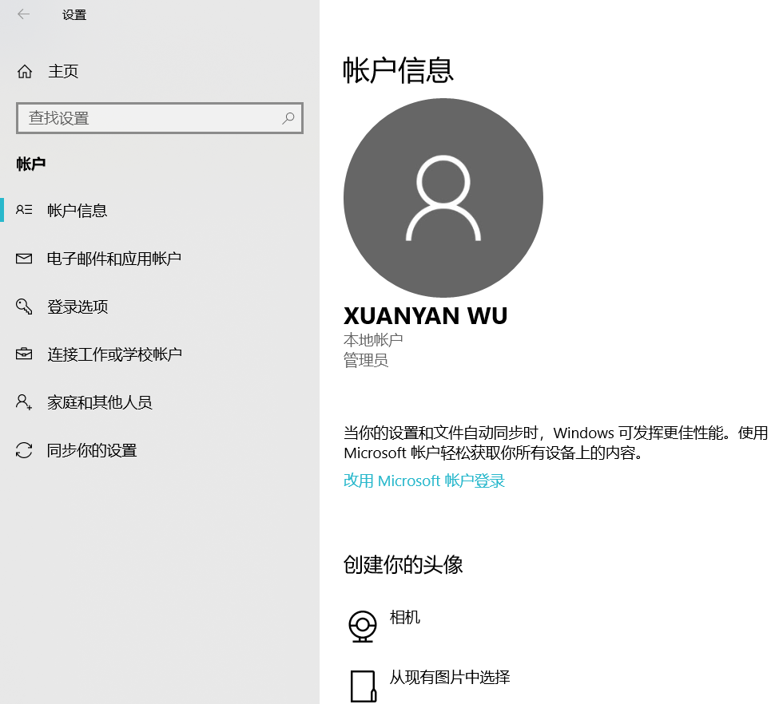

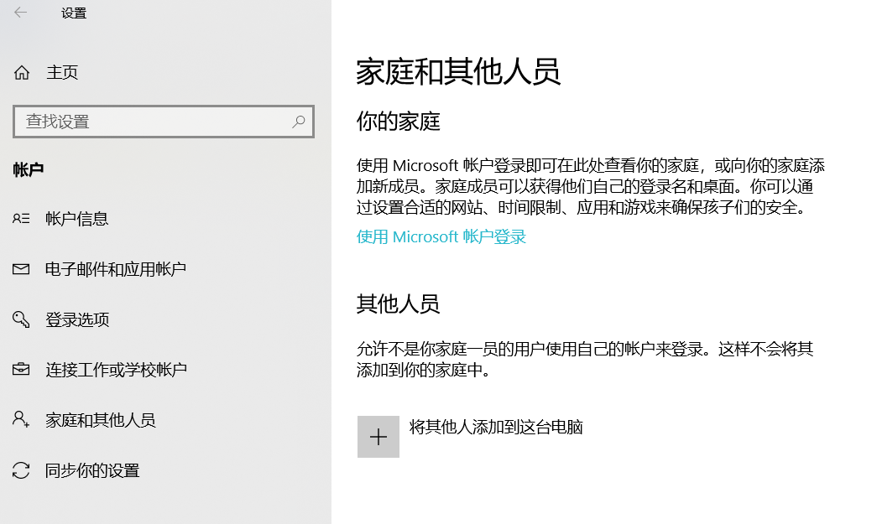

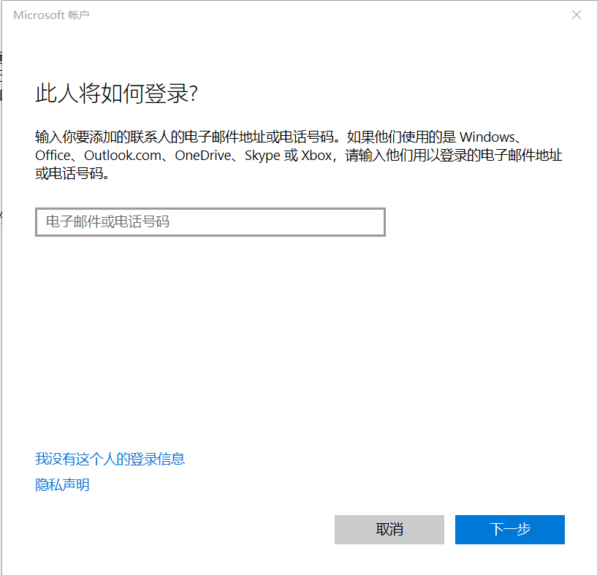

1. CREATE NEW GROUP, GIVE IT THE NAME OF YOUR MASTER’S GROUP, INCLUDE SEVERSL USERS AND ONE LOCAL GROUP INTO IT

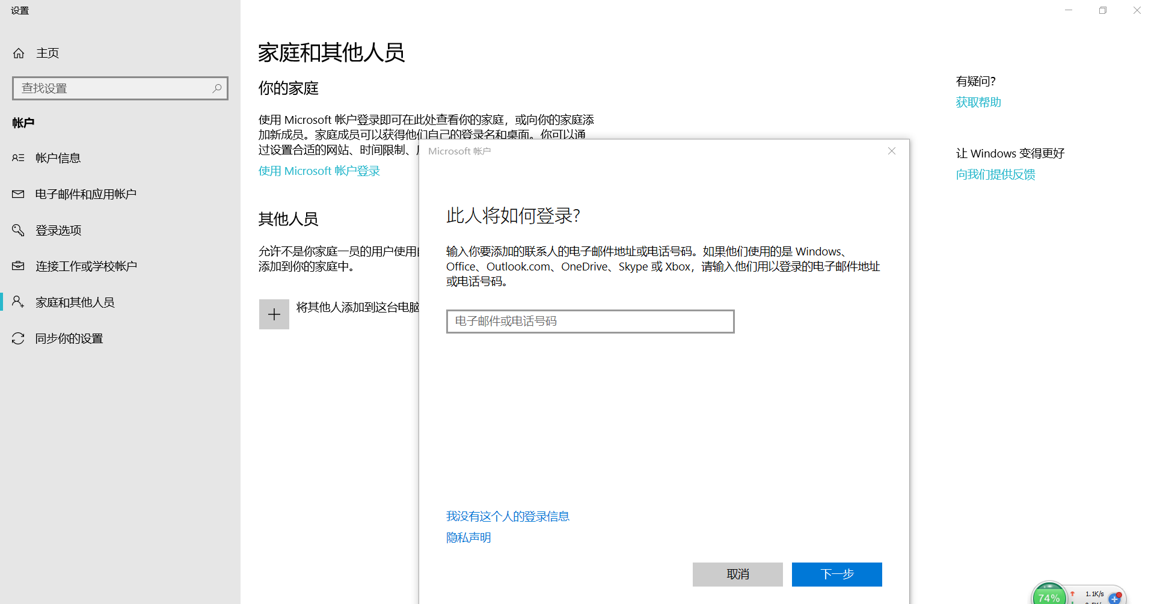

1. INCLUDE THE CREATED USER INTO “ADMINISTRATORS” GROUP

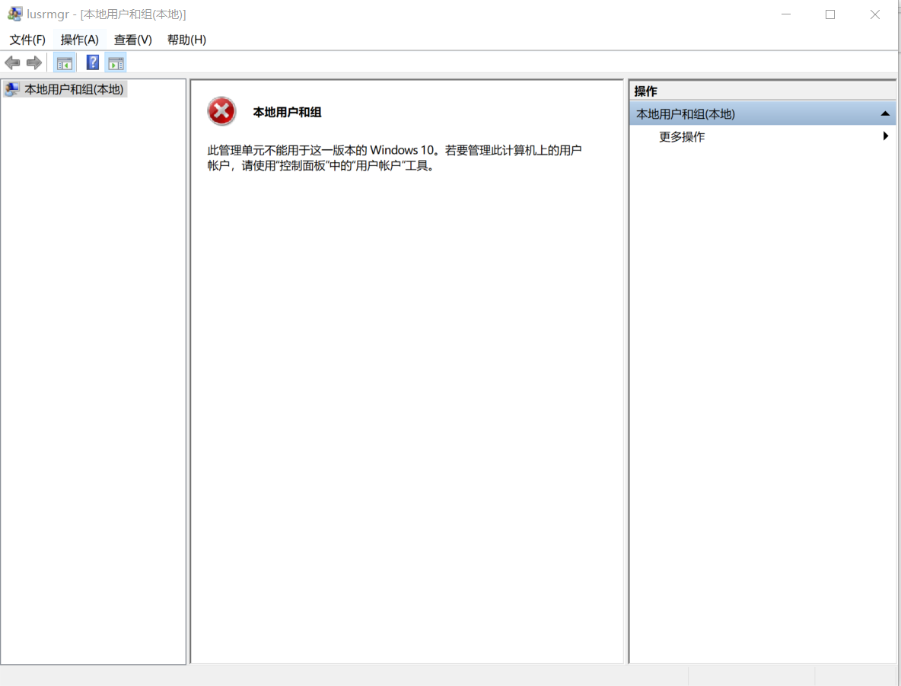

1. COULD YOU FIND PARAMETERS OF YOUR COMPUTER (HARDWARE: MAIN MEMORY VOLUME, DISK STORAGE VOLUME, NUMBER AND SIZES OF EXISTING PARTITIONS, OS VERSION)?

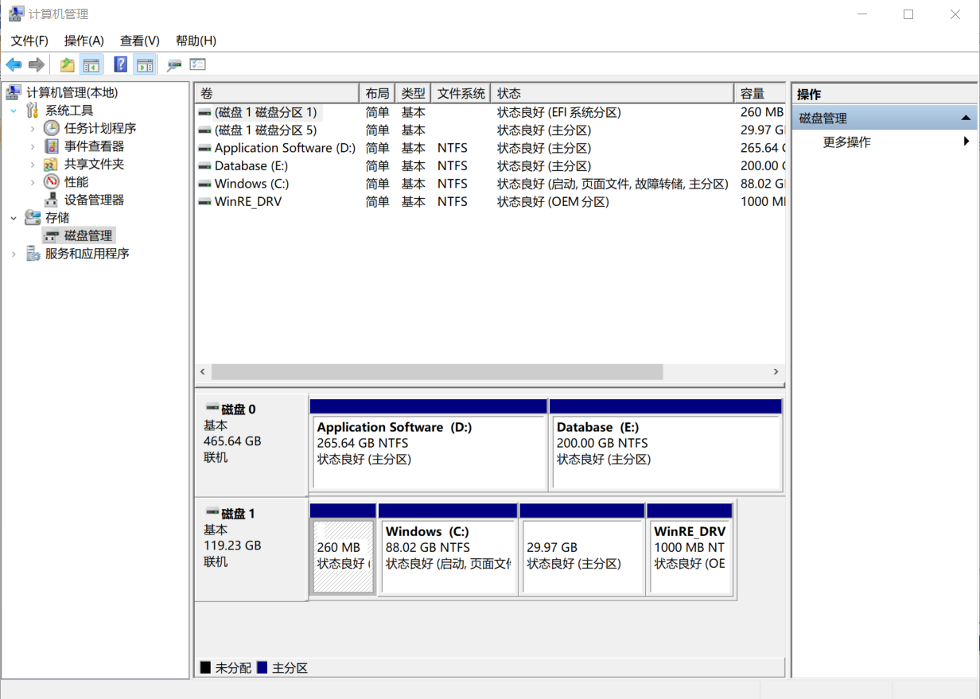

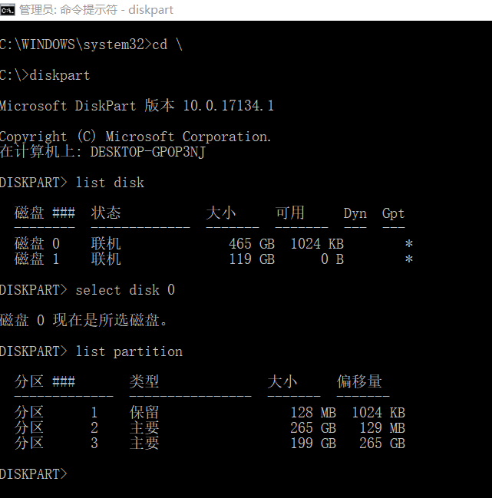

**TASK2**

1. CREATE 2 DIRECTORIES IN THE ROOT DIRECTORY WITH NAMES: DIR1 AND DIR2

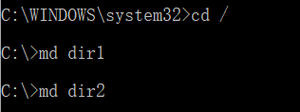

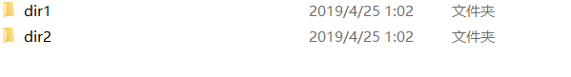

1. BY MEANS OF INPUT FROM THE KEYBOARD, CREATE A NEW FILE WITH THE NAME OF “VERY USEFUL FILE” IN THE DIR1 DIRECTORY

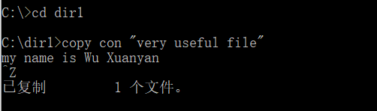

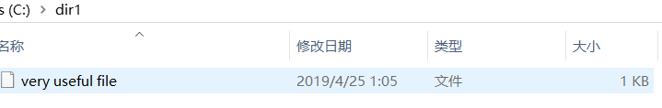

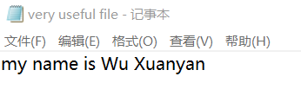

1. COPY THIS FILE TO THE DIR2 DIRECTORY WITH THE NAME OF “CORRECTED FILE.TXT”. OPEN IT IN A TEXT EDITOR (I.E. NOTEPAD) AND SLIGHTLY CHANGE ITS CONTENT.

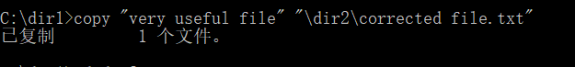

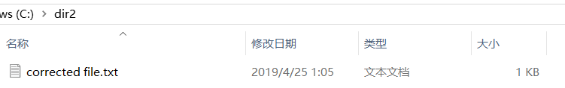

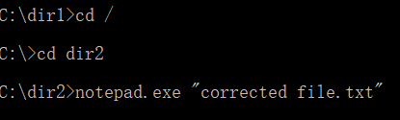

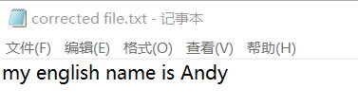

1. COMPARE THESE TWO EARLIER CREATED FILES. HOW THEIR DIFFERENCES ARE PRESENTED IN THE WINDOW?

C:\dir2\”corrected file.txt”

C:\dir1\”very useful file.txt”

Observed that the contents of the two files are different

5. SET TO THE “CORRECTED FILE.TXT” THE ATTRIBUTE “READ ONLY”.



6. CHECK WHAT IS THE WHOLE SET OF ATTRIBUTES FOR THIS FILE



7. TRY TO DELETE THIS FILE. IS THERE ANY PROBLEM?

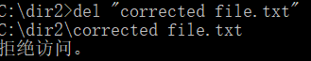

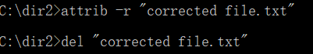

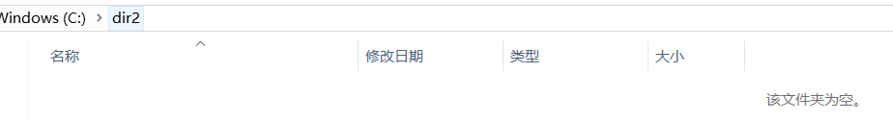

8. DELETE ALL THE OBJECTS (DIR1, DIR2, AND BOTH FILES) HAVING BEEN CREATED FOR THIS TASK

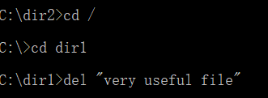

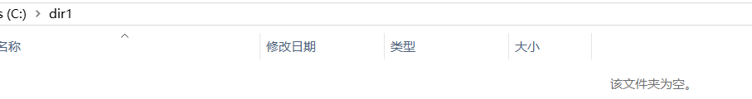

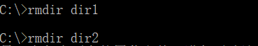

9. DISPLAY THE CURRENT DATE AND CURRENT TIME. WRITE CURRENT DATE AND TIME INTO THE “FILE-DATE.DAT” FILE IN THE ROOT DIRECTORY.

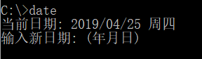

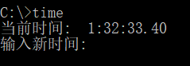

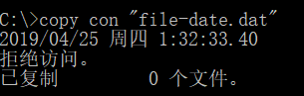

10. MAKE SURE THAT THE “FILE-DATE.DAT” FILE CONTAINS THE NECESSARY DATA

Zvereva



TASK3

CODING BATCH FILES CARRYING OUT THE FOLLOWING ACTIONS

1. ARCHIVE THE DATA STORED IN VARIOUS DIRECTORIES (INDICATED AS THE BATCH FILE PARAMETERS) INTO THE SPECIFIED DIRECTORY WITH THE PRELIMINARY CHECK THAT THIS DIRECTORY EXISTS, IF NOT – CREATE THIS DIRECTORY

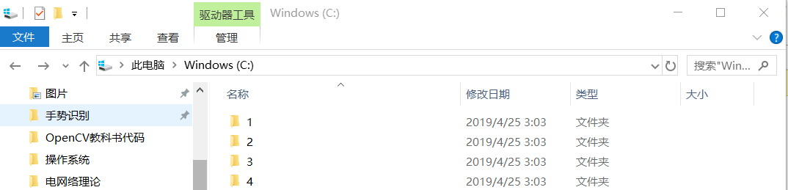





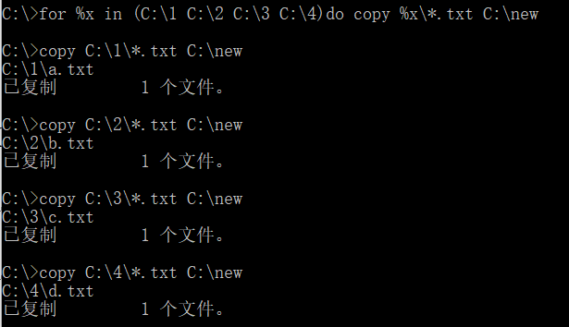

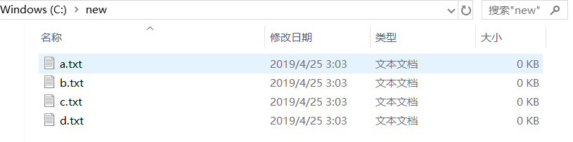

2. LOOK FOR A FILE WITH THE INDICATED AS A PARAMETER NAME IN THE DIRECTORY WHICH NAME IS DEFINED BY THE ENVIRONMENT VARIABLE “TEMP”. IF FILE WITH THE SPECIFIED NAME EXISTS, COMPARE ITS CONTENT WITH THE CONTENT OF FILE WITH THE SAME NAME IN THE HOME DIRECTORY OF THE CURRENT USER (PATH TO THIS DIRECTORY IS STORED IN THE “HOMEDIR” VARIABLE)



3. RECEIVE THE CONTENT OF THE ROOT DIRECTORIES FROM ALL EXISTING LOGICAL DISKS OF THE COMPUTER, AND WRITE IT INTO THE FILE, WHICH NAME IS THE SAME AS THE NAME OF THE COMPUTER



TASK4

1. HOW CAN YOU GUESS WHAT FILE SYSTEMS ARE USED IN DIFFERENT PARTITIONS OF YOUR DISK?

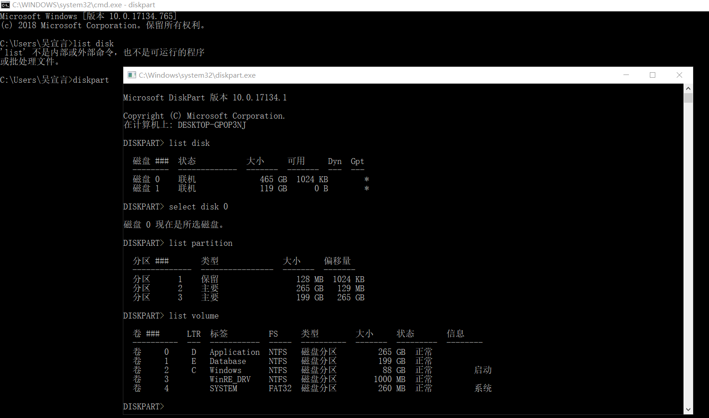

1. CREATE 2 FOLDERS: ONE – ON THE DESKTOP, ANOTHER IN THE ROOT DIRECTORY OF THE LOGICAL DISK C:

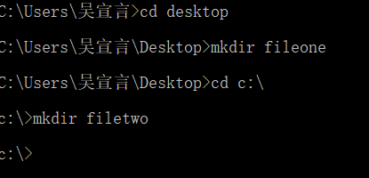

 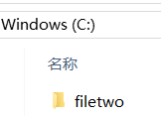

1. DO ANY PERMISSIONS EXIST? ARE THEY SIMILAR OR DIFFERENT, AND WHY?

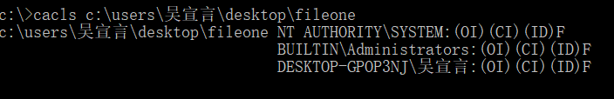

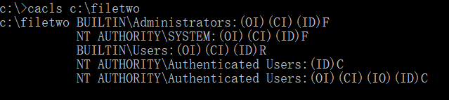

So we know they are different.

1. CREATE FILES IN THESE FOLDERS. WHICH PERMISSIONS THESE FILES RECEIVED? HOW CAN YOU CHANGE THESE PERMISSIONS?

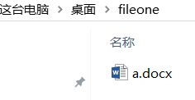 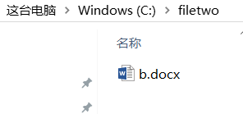

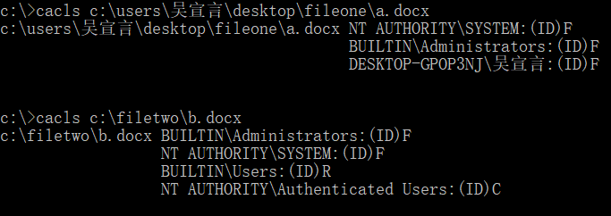

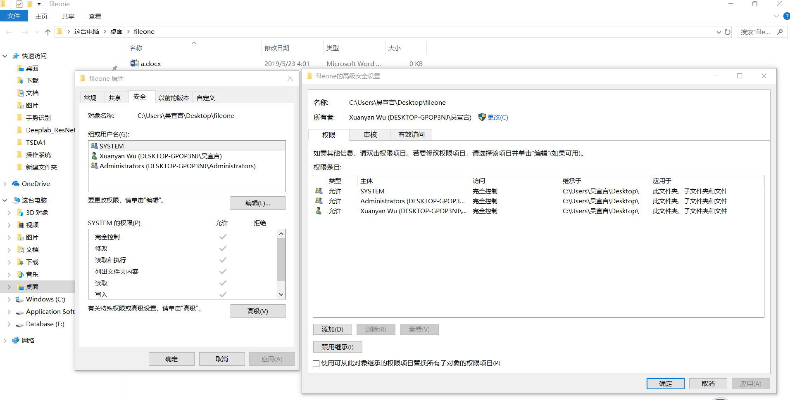

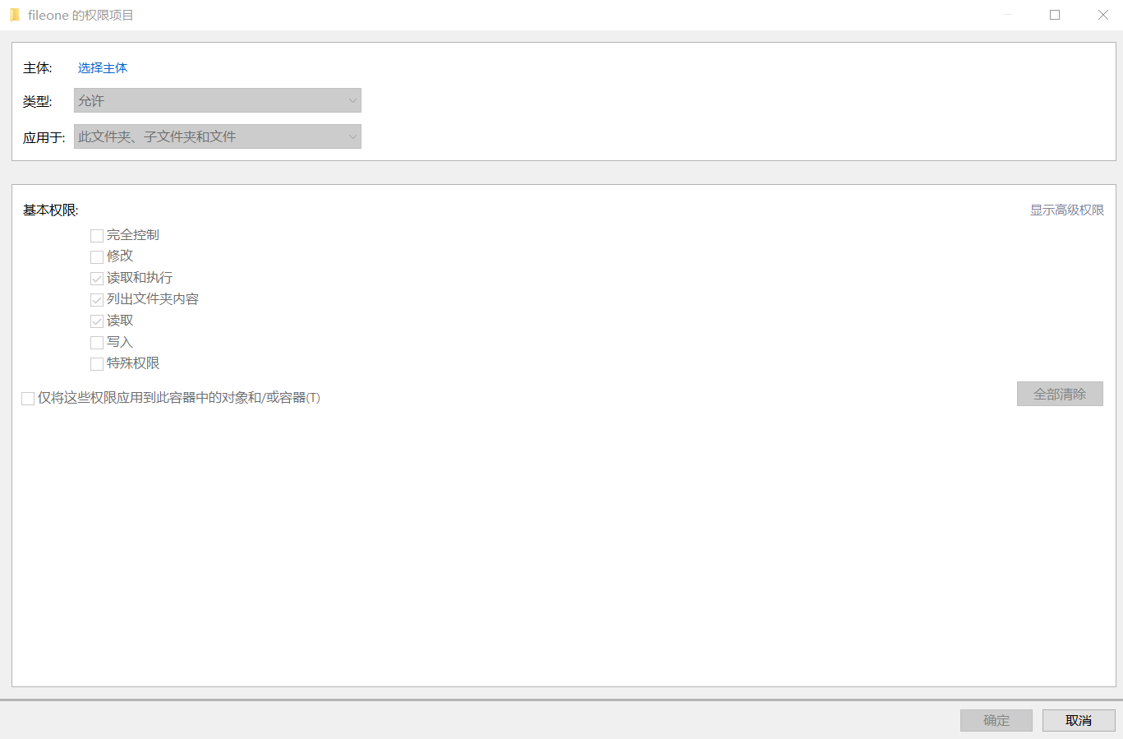

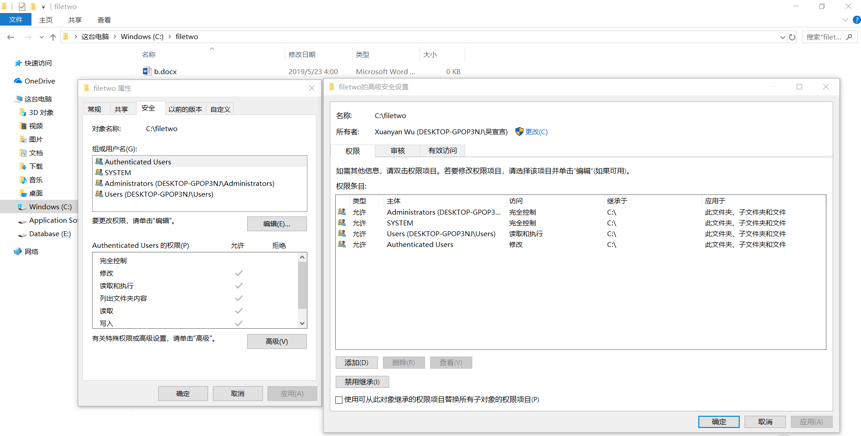

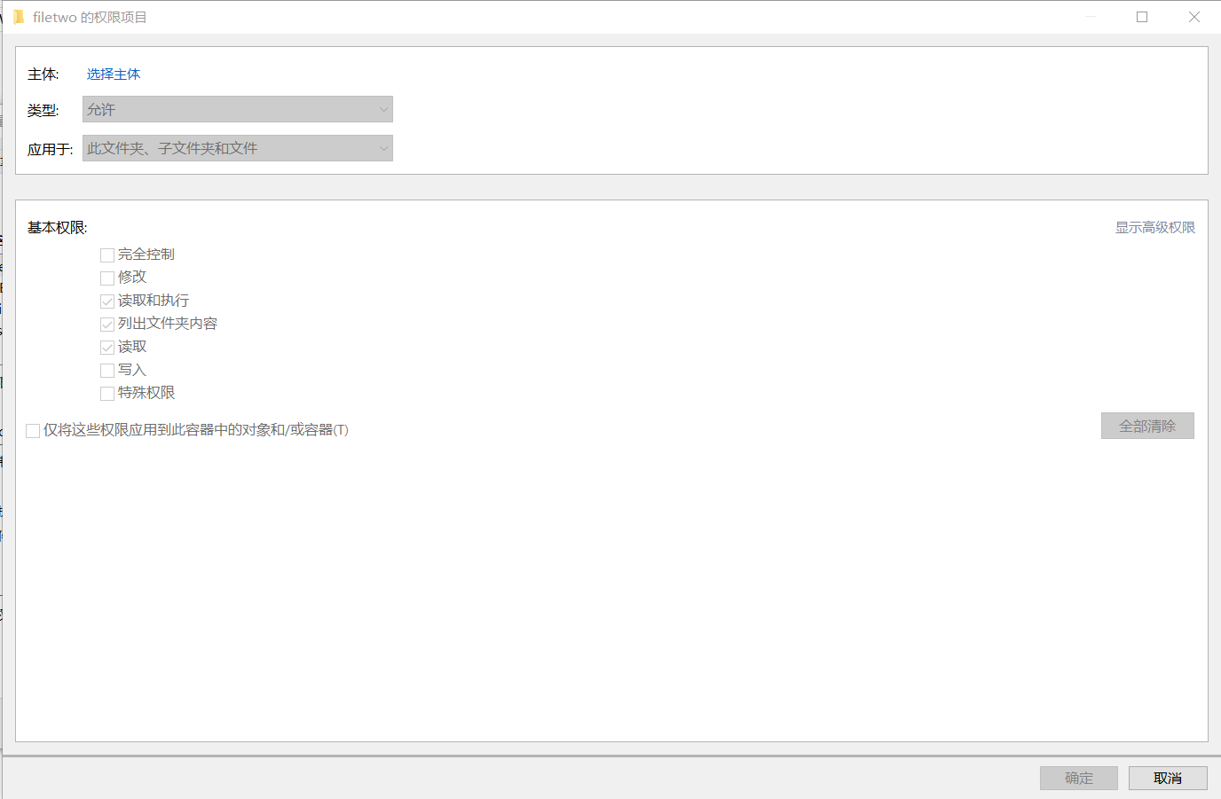

1. IMAGINE THAT THE FOLDER CREATED ON THE DESKTOP CONTAINS INSTRUCTIONS WHICH ARE RECOMMENDED TO BE READ. HOW CAN YOU TRACK THE ACTIONS OF READING THESE INSTRUCTIONS BY ALL THE USERS? COLLECT THE SCREENSHOTS OF ALL THE NECESSARY SNAP-INS.



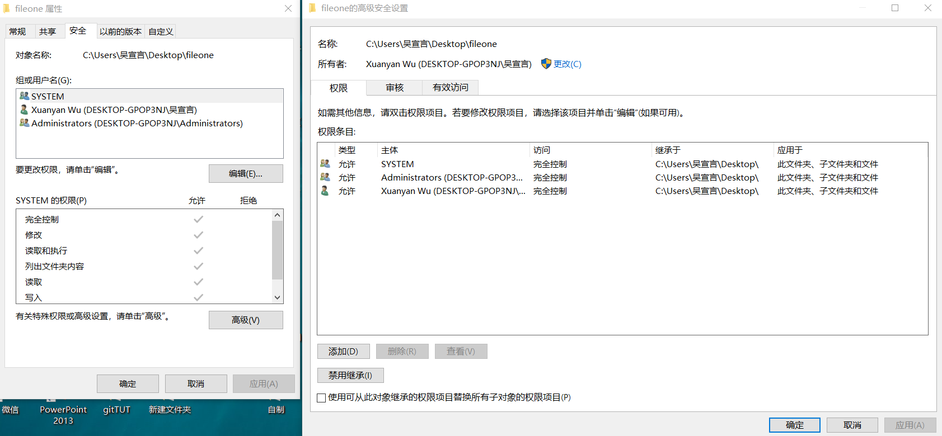

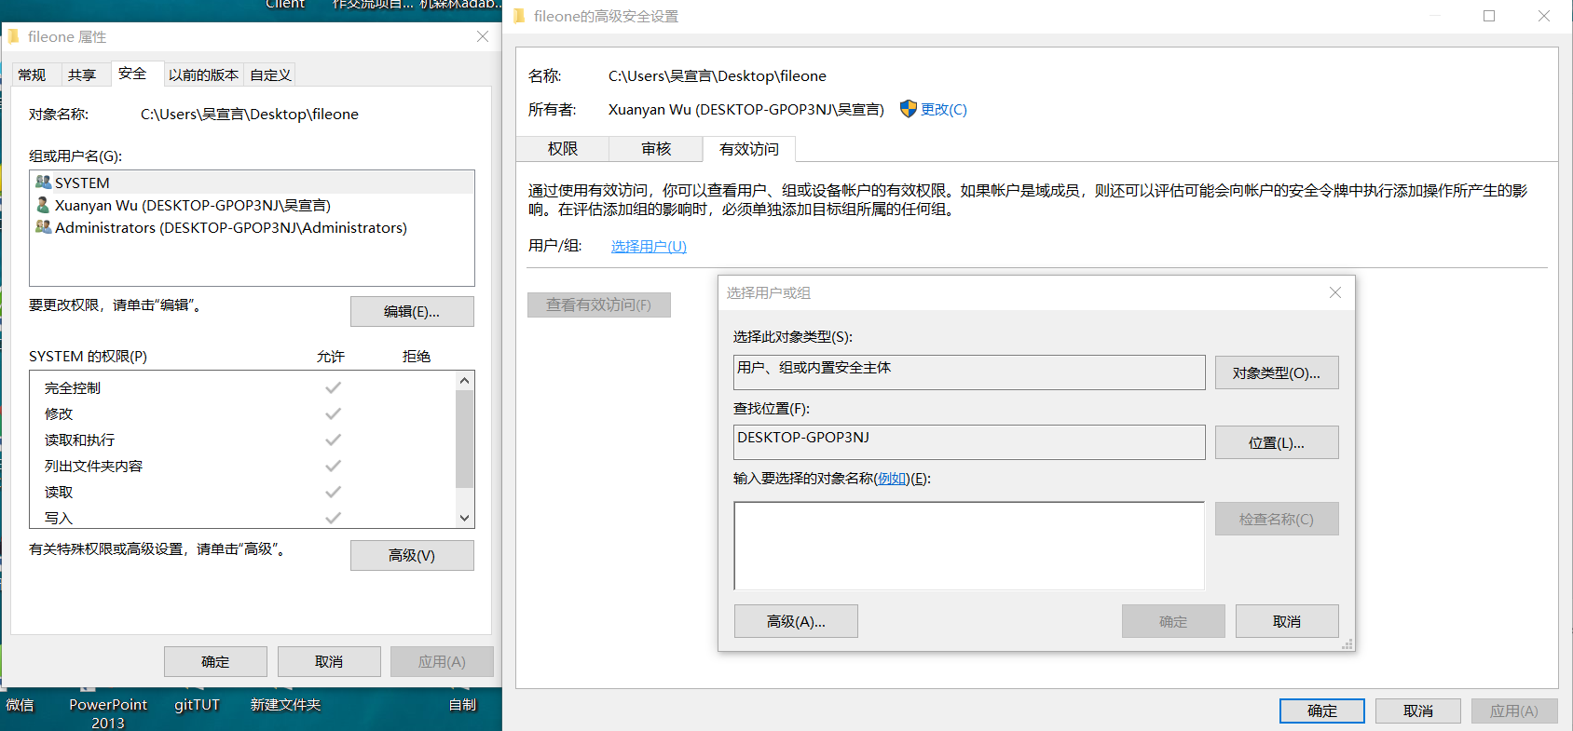

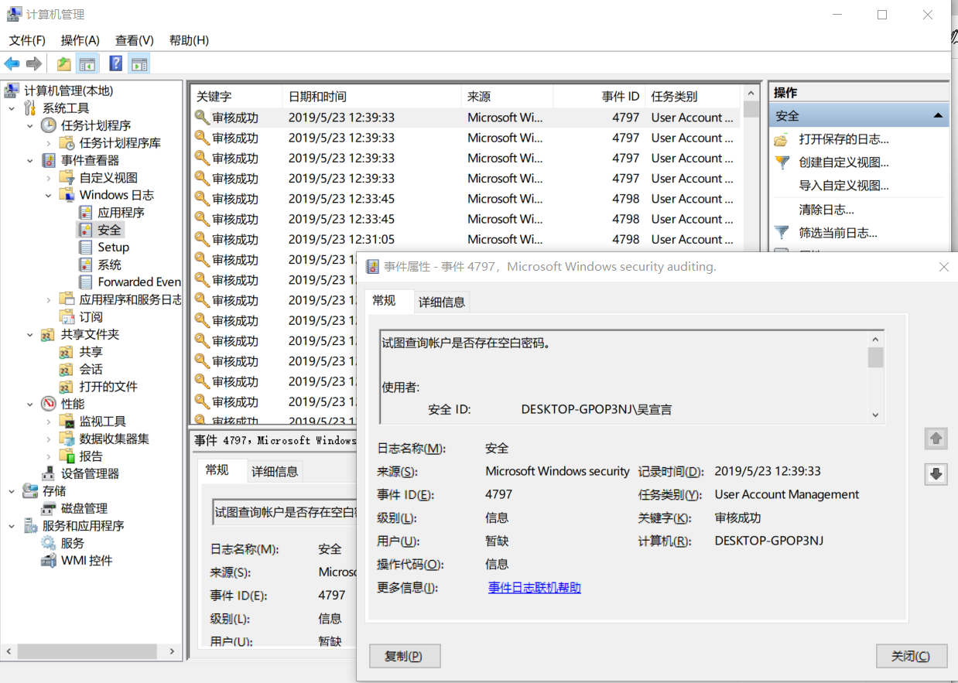

1. TRY TO COMPRESS ONE OF THE FOLDERS AND ENCRYPT ANOTHER ONE. HOW ARE THEIR ICONS CHANGED? AND WHAT ABOUT COLORS THEIR NAMES ARE VISUALIZED? HOW CAN WE CHANGE THIS SETTING (SHOW ALL FILE/FOLDER NAMES IN THE SAME COLOR)

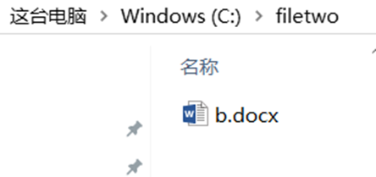

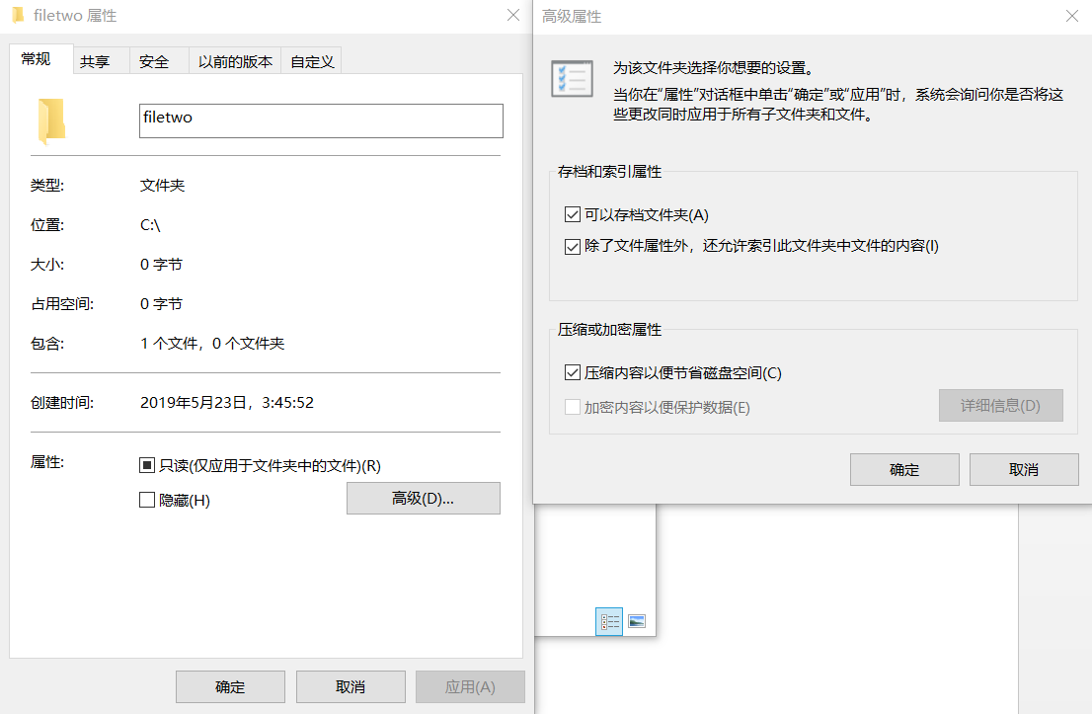

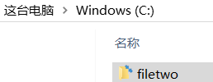

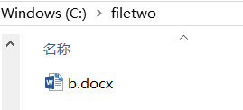

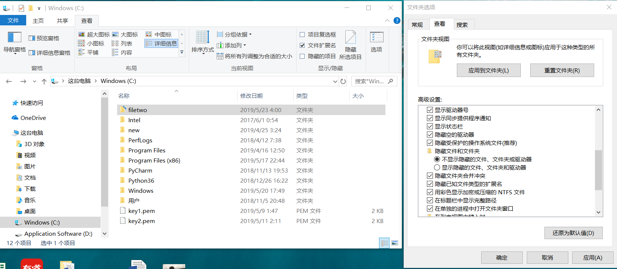

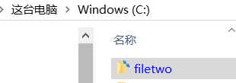

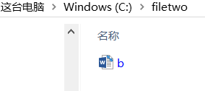

1. WHAT FOR DISK QUOTAS ARE USED? SET THE QUOTA OF 200 GB FOR EVERY USER. HOW CAN WE SET PERSONAL QUOTAS (VARIOUS FOR VARIOUS USERS)?

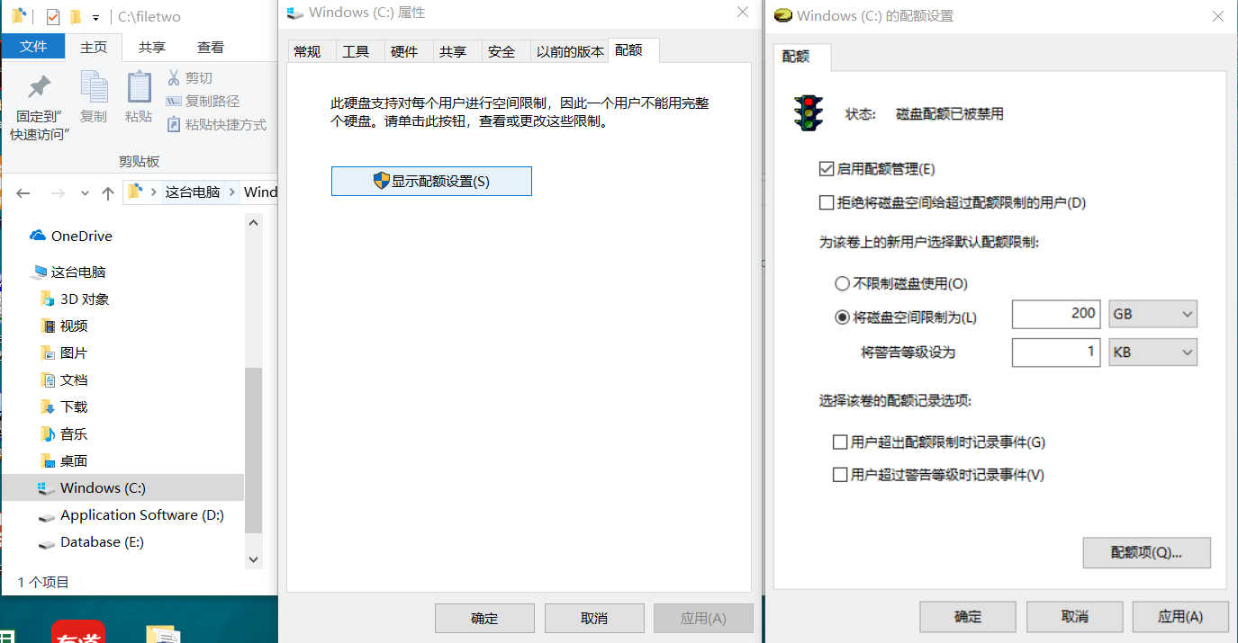

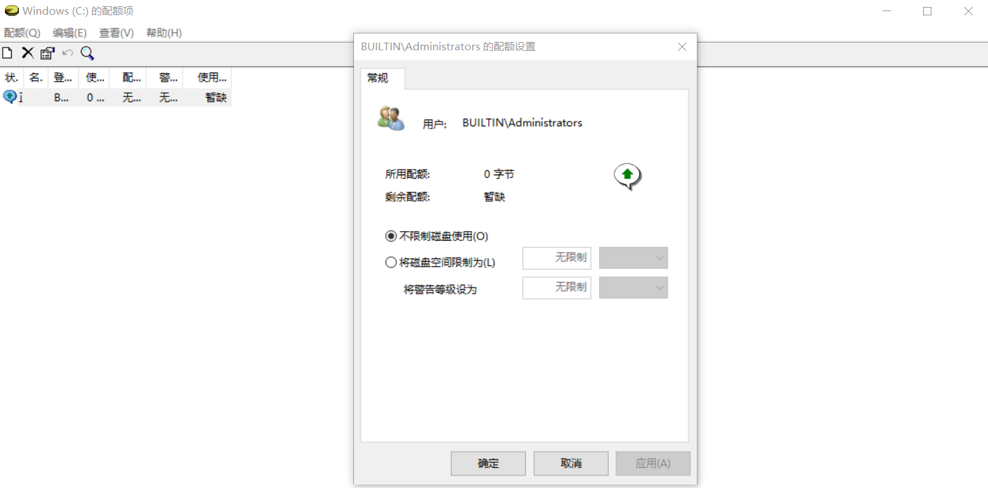

1. CREATE A WORD FILE IN THE FOLDER CREATED IN THE ROOT DIRECTORY, TYPE SOME TEXT INTO IT. CREATE SPECIAL TEXT STREAM WITH THE NAME “TEXT” AND INPUT A KIND OF FILE CONTENT DESCRIPTION INTO IT.

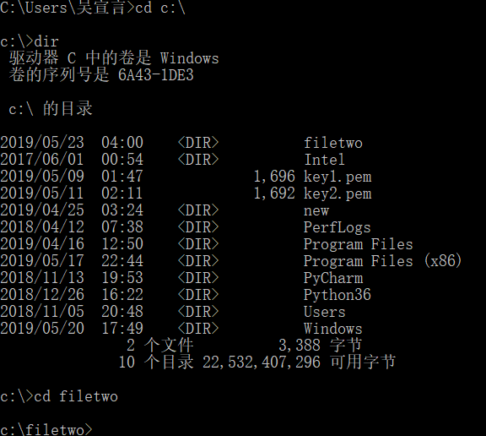

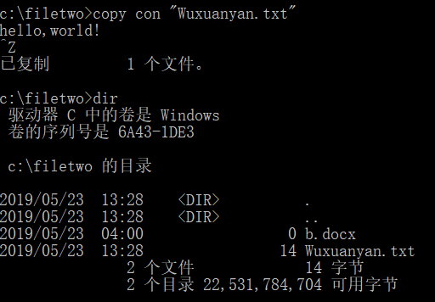

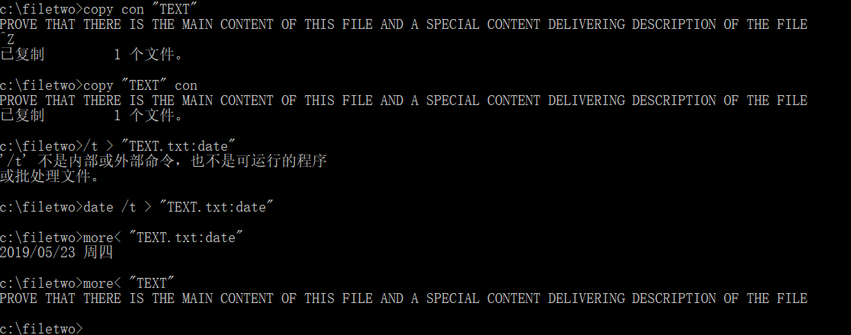

1. PROVE THAT THERE IS THE MAIN CONTENT OF THIS FILE AND A SPECIAL CONTENT DELIVERING DESCRIPTION OF THE FILE

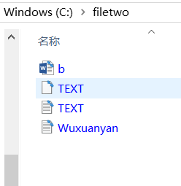

TASK5

THE GOAL IS TO ORGANIZE THE WORK WITH A FILE WITH THE SPECIFIED EXTENSION

TO ACHIEVE THIS GOAL, IT IS NECESSARY TO DO THE FOLLOWING:

1. UNDER THE MAIN KEY “HKEY_CLASSES_ROOT” CREATE THE KEY WITH THE NAME OF SPECIFIED EXTENSION (.123, FOR EXAMPLE).

2. IN THE “DEFAULT VALUE” OF THIS KEY SPECIFY THE FILE DESCRIPTOR IN ONE WORD (E.G. “SPEC_FILE”).

3. CREATE THE SUBKEY UNDER THE KEY “HKEY_CLASSES_ ROOT” WITH THE FILE DESCRIPTOR DETERMINED IN THE PREVIOUS STAGE AS THE NAME.

4. UNDER THIS SUBKEY IT IS NECESSARY TO CREATE SUBKEY “SHELL” WITH THE STRUCTURE OF THE COMMANDS WHICH WILL APPEAR IN THE CONTEXT MENU OF ANY FILE WITH THIS EXTENSION.

5. EVERY CONTEXT COMMAND IS SUPPORTED WITH THE KEY OF THE NAME (IT WILL APPEAR IN THE CONTEXT MENU) AND ITS SUBKEY “COMMAND”.

6. IN THE VALUE “DEFAULT” OF THE “COMMAND” SUBKEY, IT IS NECESSARY TO TYPE IN A REAL COMMAND (E.G. “NOTEPAD.EXE” %1 – FOR EDITING ANY FILE OF THIS EXTENSION).

7. COMMAND “OPEN” IS OBLIGATORY

